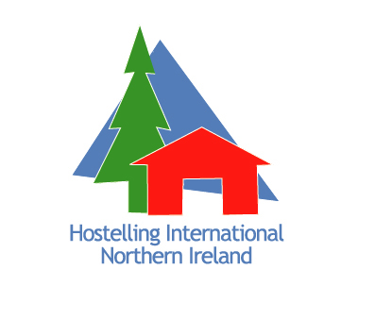  MEMBERSHIP APPLICATION FORM  PLEASE COMPLETE ALL SECTIONS  IN BLOCK CAPITALS  TITLE: _________________________________________  FORENAME:___________________________________  SURNAME: _____________________________________  D.O.B: __________________________________________  ADDRESS: ______________________________________  ________________________________________________  POSTCODE: ____________________________________  EMAIL: ________________________________________  TELEPHONE NO: _______________________________  (Please complete further details on reverse for Family Membership)  Please indicate below your preference for receiving our Annual Report (LET’S GO GREEN)*circle as applicable  *Post ≈ email ≈ I do not wish to receive Annual Report | MEMBERSHIP CATEGORIES AND FEES  Individual:  Under 25 (1 year)  Under 25 (2 year)  Under 25 (3 year)  Over 25 (1 year)  Family:  1 parent & children*  2 parents & children*  *children must be 16 yrs or under  Group:  1 year (up to 10 people)*  *valid only with a current membership card issued by HINI  OFFICE USE ONLY  Membership No: ___________________________________  Group Membership No: ____________________________  Date of issue: ______________________________________  Payment received: __________________________________ | £10.00  £16.50  £21.00  £15.00  £15.00  £30.00  Free with a valid 1 year m/ship
HOW TO PAY  Postal Applicants  Send your cheque, along with this form to: Membership Secretary, Hostelling International N.I.,  22-32 Donegall Road, Belfast, BT12 5JN.  *Please make payable to Y.H.A.N.I  PLEASE DO NOT SEND CASH  Telephone  Please ring 028 9031 5435 with your credit or debit card details. Please note that we must have received your form in order to process payment. | Gift Aid  “Yes I would like to help the Youth Hostel Association of Northern Ireland by reclaiming tax* on this membership subscription”  *I understand that I must pay an amount of income tax or capital gains tax at least equal to the tax that the Youth Hostel Association reclaims on my membership subscription in the tax year.  SIGNATURE: ______________________________________________  Donation  “Yes I would like to donate to the Youth Hostel Association of Northern”  Amount: _____________  SIGNATURE: ______________________________________________  Useful telephone numbers:  Head Office: 028 90 324 733  Belfast International Youth Hostel: 028 90 315 435  Bushmills Youth Hostel: 028 20 731 222  Whitepark Bay Youth Hostel: 028 20 731 745

Please complete ALL sections in BLOCK CAPITALS

2nd Parent (if applicable)
Title:
Forename: | Surname:
D.O.B | Male/Female:
Email: | Telephone No.:
OFFICE USE: Membership No.:
CHILDRENS SECTION (16 years and under)
Forename: | Forename:
Surname: | Surname:
D.O.B: | D.O.B:
Male/Female: | Male/Female:
OFFICE USE: Membership No.: | OFFICE USE: Membership No.:
Forename: | Forename:
Surname: | Surname:
D.O.B: | D.O.B:
Male/Female: | Male/Female:
OFFICE USE: Membership No.: | OFFICE USE: Membership No.:
Forename: | Forename:
Surname: | Surname:
D.O.B: | D.O.B:
Male/Female: | Male/Female:
OFFICE USE: Membership No.: | OFFICE USE: Membership No.:

CONDITIONS OF USE:

- That as a member using Youth Hostels, you must agree to abide by the Youth Hostel regulations of the country in which you are travelling.

- That a card is not valid unless signed.

- That as a member you undertake to contribute to the assets of the Organisation in the event of the same being wound up during the time you are a member, or within one years afterwards for payment of the debt and liabilities of the Company contracted before the time you cease to be a member and of the cost, charges and expenses of winding up the same and for the adjustment of the rights of the contributions among themselves, such amount as may be required not exceeding £1.00.

